**SARASUWATHI RAJASEGAAN,**

**UNIVERSITI TEKNOLOGI PETRONAS,**

32610, Bandar Seri Iskandar,

Perak Darul Ridzuan

Postal Address:

**No 86, Jalan Melati 11,**

**Taman Sri Melati Selayang,**

**68100 Batu Caves,**

**Selangor Darul Ehsan** 22nd May 2016

To whom it may concern:

Dear Sir/Madam,

**Application for a Job Placement**

Referring to subject above, I am Sarasuwathi Rajasegaan (NRIC: 930204-10-5842), currently have completed by undergraduate studies in Bachelor of Engineering (Hons) Chemical Engineering at Universiti Teknologi Petronas (UTP). As a young motivated individual I am interested in submitting a job application related to my experience field of study.

1. In responding to the specific requirements for a job placement, I would like to highlight how my experience can demonstrate my ability and skills.

* **Teamwork skills**: Demonstrates ability to convey thoughts and express ideas effectively in every phase of engineering and management project.
* **Research & Development**: Analyzing and investigating the tabulated data and devising strategies to work towards a solution.
* **Exceptional communication skills**: HSE auditor who understands the difference in company safety policy when working with potential service providers or colleagues.

1. In August 2015, I have completed my industrial internship in GlaxoSmithKline (GSK). Beyond my experiences and capabilities, my motivations include learning new things, the challenge of meeting the needs of an organizations and ensuring high quality outcomes.

I appreciate your time in looking through my resume and it will be a great pleasure for me to attend an interview at your convenient time.

Your contribution and support are highly respected.

Thank You.

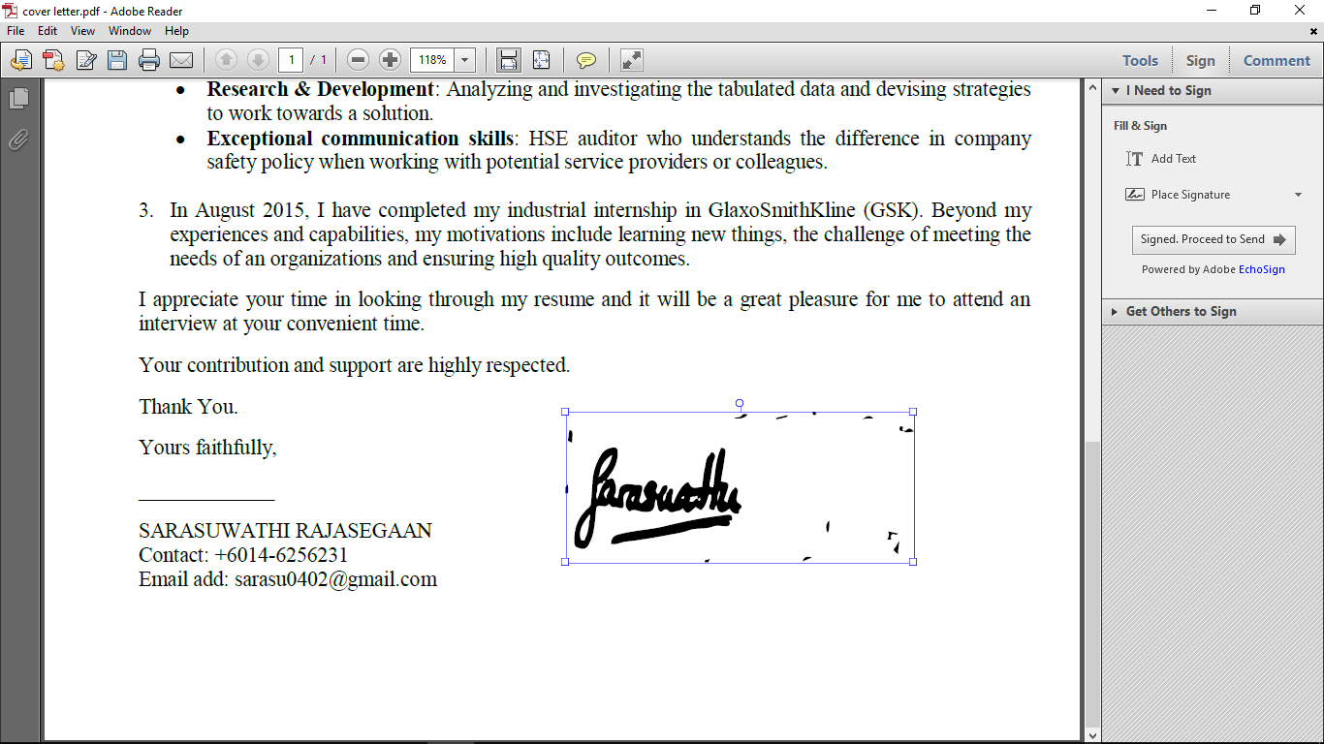Yours faithfully,

SARASUWATHI RAJASEGAAN

Contact: +6014-6256231

Email add: sarasu0402@gmail.com

|  |  |  |  |  |  |  |  |  |  |  |  |  |  |  |  |  |  |  |
| --- | --- | --- | --- | --- | --- | --- | --- | --- | --- | --- | --- | --- | --- | --- | --- | --- | --- | --- |
| C:\Users\USER\Desktop\saras pg 1.jpg  Description: Image result for personal details iconAvailability: Immediately  Personal Details:  **Date of Birth** :  4th February,1993  **NRIC** :930204-10-5842  **Gender** : Female  **Nationality** : Malaysian  **Marital Status :** Single  Description: https://s-media-cache-ak0.pinimg.com/236x/aa/a3/15/aaa315b90b293b4457c1e38a2046d55a.jpg  Mailing Address:  No,86,Jalan Melati 11,Taman Sri Melati Selayang,68100 Batu Caves,Selangor.  Description: https://s-media-cache-ak0.pinimg.com/236x/aa/a3/15/aaa315b90b293b4457c1e38a2046d55a.jpg  **Mobile:**  014-6256231  https://s-media-cache-ak0.pinimg.com/236x/aa/a3/15/aaa315b90b293b4457c1e38a2046d55a.jpg  E-Mail:  sarasu0402@gmail.com  Languages Known:  English, Malay, Tamil.    C:\Users\USER\Desktop\saras pg 4.jpg  C:\Users\USER\Desktop\saras pg 41.jpg  C:\Users\USER\Desktop\FD.jpg  C:\Users\USER\Desktop\FD.jpg  C:\Users\USER\Desktop\saras pg 42.jpg  C:\Users\USER\Desktop\saras pg 1 (1).jpgSoftware Skills: MicrosoftOffice Wordhttp://img06.deviantart.net/10ec/i/2007/183/b/8/dev_c___by_capristo.pngDev C++http://icons.iconarchive.com/icons/dakirby309/simply-styled/256/Microsoft-Excel-2010-icon.png ProgrammingMicrosoft OfficeExcelhttp://admin.utep.edu/Portals/1804/Skins/HelpDeskSkin-2col/Software/Autocad_Icon.pngAutoCADMicrosoft PowerPoint 2010 iconMicrosoft PowerPointMatlab CentralMATLAB Microsoft Office Publisher icon Microsoft OfficePublisherFile:Adobe Photoshop CS6 icon.pngAdobe Photoshop | **SARASUWATHI RAJASEGARAN**  **BACHELOR OF ENGINEERING (HONS) CHEMICAL ENGINEERING**  **MAJOR: ENVIRONMENTAL ENGINEERING**  **Career Objective**  To perform, utilizing my skills and knowledge, in a manner which will lead to the successful growth of the organization and which will also land me in a successful career.  **EDUCATION HISTORY**   |  |  |  | | --- | --- | --- | | **UNIVERSITY/SCHOOLS** | **YEAR** | **GRADE** | | UNIVERSITI TEKNOLOGI PETRONAS | 2011-2015 | **GPA : 3.50** **CGPA : 3.22** | | S.M.K ST.MARY | 2006-2010 | **SPM : 10A, 1B+**  **PMR : 8A** | | S.J.K (T) BATU CAVES | 2000-2005 | **UPSR : 6A, 1B** |   **PROJECTS**  **Final Year Project**  **Model Predictive Control For Tracking**  Analyze the effect of tuning parameters on the control controllers. It involves the  latest economic issues in various process industries which has uses the  application of control systems.  **Plant Design Project**  **Design of Glycerol-To-Epichlorohydrin(GTE) Plant**  Group work to produce an optimum production plant of epichlorohydrin. Involved process designing, instrumentation & control, safety, economic and cost estimation (opex & capex) and wastewater treatment plant.  **INTERNSHIP & WORKING EXPERIENCES**  http://www.gsk.com/assets/img/gsk-logo.png**GLAXOSMITHKLINE MALAYSIA** ***Engineering Intern***  -Major task accomplished including monitor and troubleshoot utilities and wastewater treatment plant (WWTP)-Designed a new layout for emergency shower station in order to reduce legionella  - Involved in audits of Engineering department, HSE department, Quality department and ISO audit  - Learnt on SOP documentations and applied  **Visited PETRONAS Penapisan Melaka** during field trip under chemical engineering department.**Worked at PETRONAS Twin Tower KLCC Sky bridge** as a volunteer. Learned a lot of soft skills, communication skills and how to manage visitors.  **Extra CurricULlars & Achievements**   * **OPEN INNOVATION CHALLENGE(OIC) SEDEX 31ST**Won bronze medal and also best presenter group. Project title is Coal-microalgae fired power plant. * **UTP RUN 2013**Run under UTP Convofair 2013 women open challenge for 10km. Won 11th placing. * **UTP SPORTS CARNIVAL 2014**Road Relay (4x 3km) under female category. Won 2nd runner up representing chemical department. * **UCRN FUTSAL COMPETITION**UTP Colors of Ranggoli Night organized futsal competition for female category. Won 1st runner up. * **UTP COLORS OF RANGGOLI NIGHT 2012 & 2013**Performed classical dance and western dance for the event   **LEADERSHIP EXPERIENCES**   * Assistant Director of Entrepreneurship & Sponsorship in IChemE-UTP-SC 2013-2014 * Director of Human Resource and Management in MAFEST 2014 * Secretary of SANGEETH 2013-2014 * EXCO of Performance department in UTP COLORS OF RANGGOLI NIGHT (UCRN) 2014   **ACADEMIC COURSES**   |  |  | | --- | --- | | * Physical Chemistry * Organic Chemistry * Fluid Flow and Transport Process * Principles of Chemical Engineering * Engineering Drawing * Heat Transfer Design * Mass Transfer Design * Chemical Engineering Thermodynamics * Separation Process * Analytical Chemistry * Structured Programming and Database System | * Unit Operation Lab I & II * Chemical Process Dynamic, Instrumentation and Control * Kinetics & Reactor Design * Engineering Economics and Entrepreneurship * Engineering Team Project * Process Plant Design * Advanced Transport Process * Process Instrumentation and Control Lab * Health, Safety and Environment |   C:\Users\USER\Desktop\saras pg 13.jpgC:\Users\USER\Desktop\saras pg 13.jpgC:\Users\USER\Desktop\saras pg 13.jpgC:\Users\USER\Desktop\saras pg 13.jpgChemical Engineering Core  Specialization   |  | | --- | | * Air Pollution Engineering * Solid & Hazardous Waste Management * Industrial Effluent Engineering |   **referees**   |  |  | | --- | --- | | DR. M. RAMASAMYAsscociate ProfessorChemical Engineering DepartmentUniversiti Teknologi PETRONASBandar Seri Iskandar,31750, Tronoh,Perak Darul Ridzuan.Tel : 05-3687585  Email : marappagounder@petronas.com.my | ASMIDI FARHAN BIN MASHANFacility EngineerColgate Palmolive (M) SDN.BHDJalan Semangat seksyen 1346200, Petaling Jaya,Selangor Darul Ehsan  Tel : 017-336 7750  Email : asmidi_farhan_mashan@colpal.com | |

